**Assignment - 2**

**OPERATING SYSTEM**

**TOPIC: BASIC SHELL PROGRAMMING**

*(NAME -Akash Chowdhury,Class Roll - 36,Registration Number - 304202200600036*

*Enrollment No. - 12022006015036)*

1. Write a shell program to calculate the sum of two numbers. (using 3rd variable)

Code-

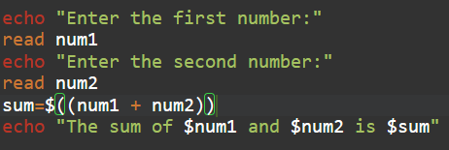

Output-

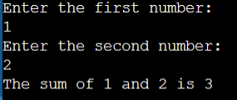

2) Write a shell program to calculate the sum of two numbers. (without using 3rd variable)

Code-

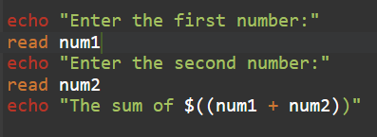

Output-

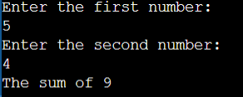

3)Write a shell program to calculate the difference between two numbers. (using 3rd variable)

Code-

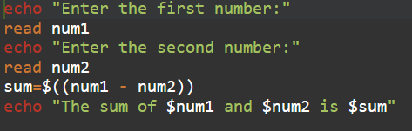

Output-

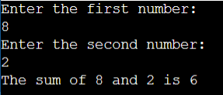

4)Write a shell program to calculate the difference between two numbers. (without using 3rd variable)

Code-

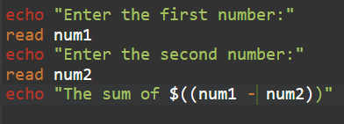

Output-

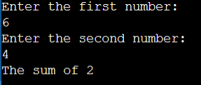

5)Write a shell program to calculate the product of two numbers.

Code-

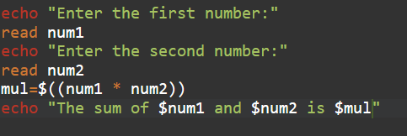

Output-

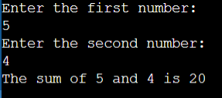

6)Write a shell program to find the division of two numbers.

Code-

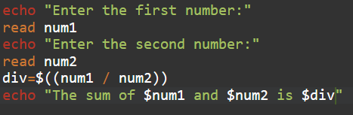

Output-

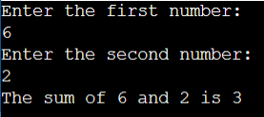

7)Write a shell program to calculate the average of three numbers.

Code-

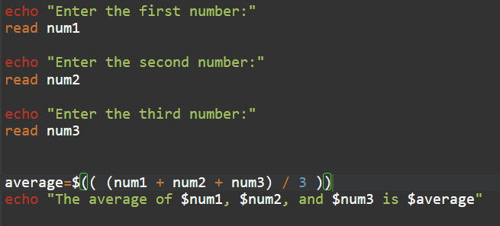

Output-

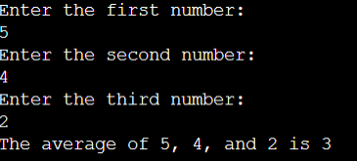

8)Write a shell program to find the area and perimeter of a rectangle.

Code-

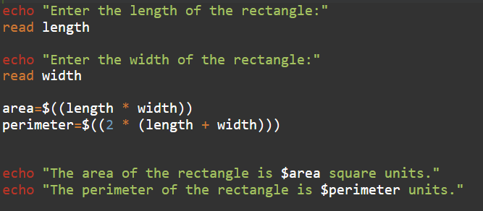

Output-

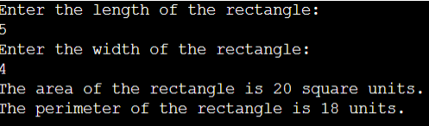

9)Write a shell program to find the area and perimeter of a square.

Code-

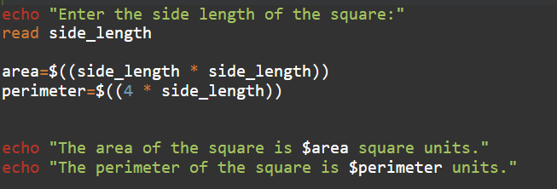

Output-

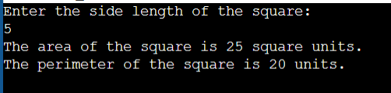

10)Write a shell program to find the square root of a number.

Code-

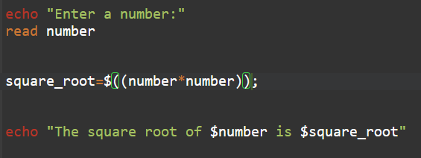

Output-

